Report of | Meeting | Date
Director of Change and Delivery  (Introduced by Leader of the Council and Cabinet Member (Strategy and Reform) | Council | Wednesday, 20 July 2022
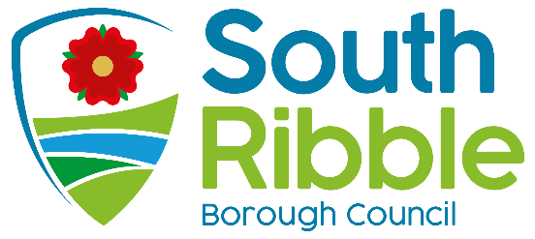

LGA Peer Review Revisit
Is this report confidential? | No

Is this decision key? | Not applicable

Purpose of the Report
- This report presents the outcome of the Local Government Association (LGA) peer review six-month revisit which took place on-site in April 2022, following the virtual peer review in July 2021.

Recommendations to Council
- That Council note the report and progress to date.

Reasons for recommendations
- To support a commitment to the continuous improvement of South Ribble Borough Council.

Other options considered and rejected
- No other options have been considered.

Executive summary
- This report provides a summary of the feedback from the Local Government Association (LGA) peer review revisit, following the full peer review which took place in July 2021. The revisit report highlights the progress that has been made in delivering the action plan in response to peer recommendations and encourages the council to continue to focus on key areas of improvement. The revisit report is included at appendix 1.

Corporate priorities
- The report relates to the following corporate priorities:

An exemplary council | Thriving communities
A fair local economy that works for everyone | Good homes, green spaces, healthy places

Background to the report
- The LGA peer review took place in July 2021 as a virtual exercise due to the restrictions in place as a result of Covid-19. The report and recommendations were published at the time along with an action plan setting out how the council would respond.

- In summary, the peer team recognised the promising nature of the work to date and outcomes in relation to governance that have been achieved, while delivering effective services throughout the pandemic and continuing to change ways of working including the implementation of shared services.

- The peer team identified 8 recommendations to support continued improvement through a combination of ‘quick wins’ and longer-term objectives.

- Embed a culture of good governance
- Provide full clarity on the ambition and plans for shared services
- Programme Plan for future work and political priorities
- Medium Term Financial Strategy
- Assurance on capital programme delivery
- Organisational development and Management Practice:
- Community Hubs
- Political engagement in a balanced authority

- An action plan was developed to set out the council’s response to the recommendations. The plan was implemented, and key actions successfully delivered ahead of the revisit.

- The peer review six-month revisit is a standard part of the process to check up on progress. Given the limitations of the original review, the peer team requested to visit the council on-site at the Civic Centre which took place on the 5th and 6th April 2022.

Summary of the revisit report

- Through this six-month progress review, the peer team acknowledged the robust action plan developed in response to the original recommendations, which included demonstrable examples, such as the approval of a refreshed Corporate Plan, revisions to the Council’s Treasury Management Strategy, and an improved financial position reported through the Medium-Term Financial Strategy.

- The team found that the positive response of the council has contributed to several fundamental improvements across governance, performance improvement and people management, which is a continuation of the council’s progress in recent years.

- The peer team also highlighted the benefits of spending time on site with the council and the greater insight this provided into the council’s relationship with communities through community engagement and the community hubs.

- The revisit report confirms that there are still opportunities to improve in relation to key challenges, which will form part of an ongoing commitment to deliver exemplary council services in line with the Corporate Strategy priorities.

Climate change and air quality
- The work noted in this report has no impact on the Councils Carbon emissions and the wider Climate Emergency and sustainability targets of the Council.

Equality and diversity
- There are no equality and diversity considerations for this report.

Risk
- The Strategic Risk Register records risks to organisational performance and improvement.

Comments of the Statutory Finance Officer
- No comment

Comments of the Monitoring Officer
- No comment

Background documents
LGA Corporate Peer Challenge Final Report 2021 (southribble.gov.uk)

Appendices
Appendix 1 – Corporate Peer Challenge – Six Month Progress Review

Report Author: | Email: | Telephone: | Date:
Victoria Willett (Director of Change and Delivery) | victoria.willett@southribble.gov.uk | 01772 625625 | 01/07/2022

